**Online Calculator System Design Document**

Table of Contents

Purpose 3

Problem 3

Assumptions 3

Scope 3

Design Diagram 3

Class Diagram 3

Code Map Diagram 4

Sequence Diagram 5

Implementation Details 5

Approach 5

Code 6

Extensibility 6

Deployment 6

Testing 6

Unit Tests 6

Manual Verification 7

Scalability 8

Reliability 8

Limitations 8

# Purpose

The purpose of this document is to describe system design and implementation details for Online Calculator.

# Problem

Provide system design for an Online Calculator. The Online Calculator should support:

1. Parsing complex arithmetic expressions e.g. (4+2) x 4 / 2

2. Should support Memory Save and Recall e.g. <MR> + 3

3. Bonus: Memory Save should persist across sessions

         4. Bonus: Memory save for one user should not be visible to other users

# Assumptions

# Scope

To provide design and implementation details on online calculator that can evaluate a simple infix expression and provides basic support for session and memory management.

# Design Diagram

## Class Diagram

The below class diagram is generated using Visual Studio 2019 by Class Designer extension.

**Class diagram for Online Calculator App**

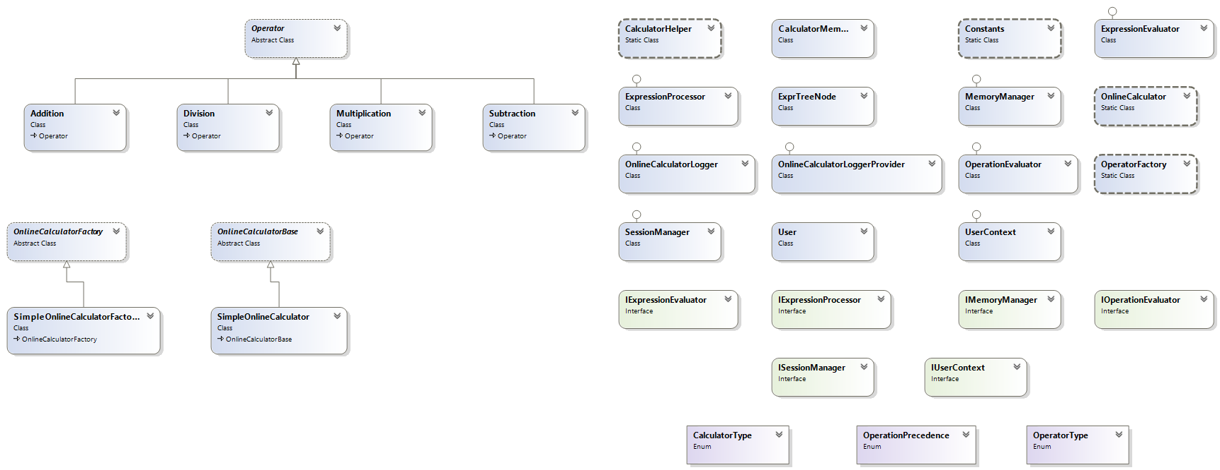

## Code Map Diagram

The following code map diagram shows the call interaction and dependency between different objects of the application.

Color indicator

|  |  |
| --- | --- |
| Arrow Color | Category |
| Green | Inheritance |
| Pink | Calls |
| Grey | Return |
| Dotted Green | Interface |

## Sequence Diagram

The sequence of actions between the objects while evaluation expression is depicted in the below sequence diagram.

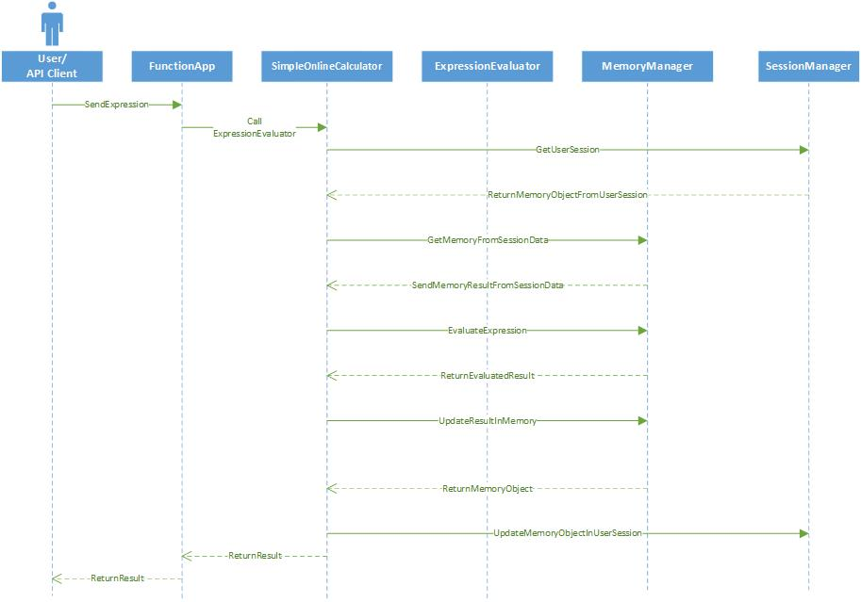

# Implementation Details

## Approach

Implemented as Azure Function App using .NET Core 3.0 in C# language. The application is implemented in extendable approach by following required software design patterns and SOLID principles.

This calculator supports the following features

1. Evaluates the arithmetic expressions with basic operations like Addition, Subtraction, Multiplication and Division.
2. Once the expression is evaluated the result will be stored in session of the user.
3. The result will be managed across session of the user.
4. The memory of one user will not be visible to another user.
5. The memory can be recalled using operator ‘**R**’.
6. The recollected memory can also be used in operations.

## Code

Code is deployed into a GitHub repository.

GitHub repo : [BalajiDabbara/mmd-test-projects (github.com)](https://github.com/BalajiDabbara/mmd-test-projects)

Follow the below steps to run the app

1. Clone the Git repo
2. Open Visual Studio 2019 in administration mode.
3. Open the solution file ***(\OnlineCalculator\Online Calculator App \Online Calculator App .sln***)
4. Build the solution
5. Run the App (Ctrl + F5)
6. Local function app will be started.
7. Test using Postman or any other API tester.

# Extensibility

This app is designed which can be extended further in the future. The following operations are not supported in the current implementation and can be extended.

* Implemented to be extended to different type of operators.
* Advanced calculator.
* Custom logger for telemetry logging.
* Unary operator
* Double digit operators.
* User level authentication.
* On-demand Save
* Multi-level Save.
* Dependence injection container.
* Durable function app.
* Memory clear.
* Advanced Session management.

# Deployment

The Online Calculator App function app is deployed in Azure cloud as a Function App.

# Testing

Online Calculator App is tested by unit tests with xUnit framework and evaluated the API using Postman.

Added unit tests are added in the project ***Online Calculator App .Tests***

### Unit Tests

Added unit tests are added in the project ***Online Calculator App .Tests***

Following are the different test scenarios added for the function app.

1. ValidateInfixExpressionEvaluationSuccess
2. ValidateInfixExpressionEvaluationFailedOnInvalidInput
3. ValidateInfixExpressionEvaluationSuccesssOnAllOperators
4. ValidateEmptyUserNameThrowsAnError
5. ValidateMemoryRecall
6. ValidateOperationOnMemoryRecall
7. ValidateMemoryRecallForDifferentUsers

### Manual Verification

Online Calculator App API functionality can be validated using Postman. The URL and request body to be passed for the request should be as shown below.

Azure Deployed Function App API URL:

https://onlinecalculatorapp.azurewebsites.net/api/OnlineCalculator_Evaluate

|  |  |
| --- | --- |
| Function App URL | https://onlinecalculatorapp.azurewebsites.net/api/OnlineCalculator_Evaluate |
| Content Type | JSON |
| Request Body | {  "UserName": "Balaji",  "InfixExpression": "(((2+2)*4/2+2))*10/5*2*100"  } |
| Response Body | Hello, Balaji. Your input expression ((((2+2)*4/2+2))*10/5*2*100) has been evaluated to : 4000. |

##### Postman

##### Azure App Verification

# Scalability

Online calculator scalability

This can be scaled as a service in

# Reliability

Online calculator reliability

# Limitations

Online Calculator App has following limitations.

* Double or more letter operators are not supported (e.g.: ++, --, log, sin, cos).
* Multiple expression validations.
* Specific exceptions.
* Not tested for Throttling conditions.
* Not validated session time.